* Coordinator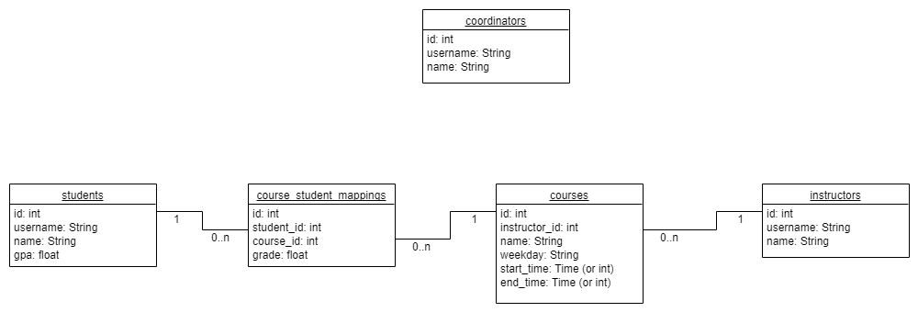
  + Has…
    - An id (integer, primary key)
    - A username (string)
    - A full name (string)
* Instructor
  + Has…
    - An id (integer, primary key)
    - A username (string)
    - A full name (string)
  + Has many…
    - courses (Course, foreign key instructor_id references this.id)
* Student
  + Has…
    - An id (integer, primary key)
    - A username (string)
    - A full name (string)
    - A GPA (floating-point number)
  + Has many…
    - courseMappings (CourseStudentMapping, foreign key student_id references this.id)
* Course
  + Has…
    - An id (integer, primary key)
    - A name (string)
    - A weekday (string)
    - A startTime (Time)
    - An endTime (Time)
  + Has one…
    - instructor (Instructor, foreign key instructor_id references instructor.id)
  + Has many…
    - studentMappings (CourseStudentMapping, foreign key course_id references this.id)
* CourseStudentMapping
  + Has…
    - An id (integer, primary key)
    - A grade (floating-point number)
  + Has one…
    - student (Student, foreign key student_id references student.id)
    - course (Course, foreign key course_id references course.id)